Master Functional Document

Application | NGERP - Centra
Service Bundle | Master Management
Service Request | Scheduler Email Configuration

Description :

User’s can be added to the scheduler recipient to receive status of the database job via email.

Workflow Process :

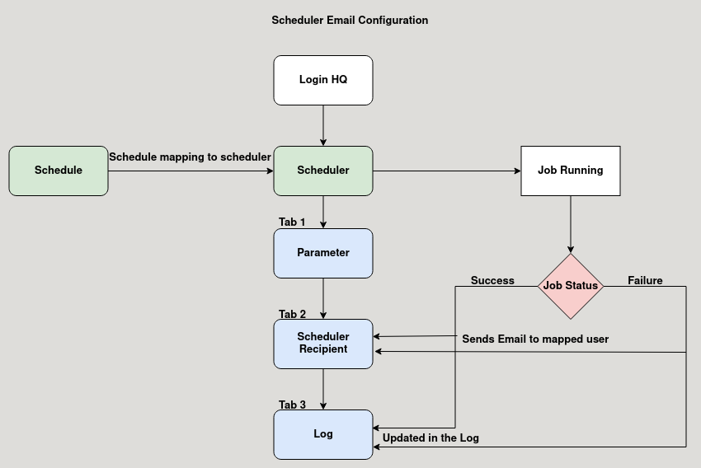

Business Rules :

- Click test run to run the Database job, after the job completed it shows success message.
- A schedule is mapped to the scheduler master to run the job at specific time and day.
- Either the job is success or failure, user can check the details in the log tab.
- The scheduler recipient tab is used to map user to send email alert about the job status.
- Job status of the scheduler is sent to the user inspite of success or failure.

